- Display empno, ename, deptno from employee table. Instead of display department numbers display the related department name (Use decode function).
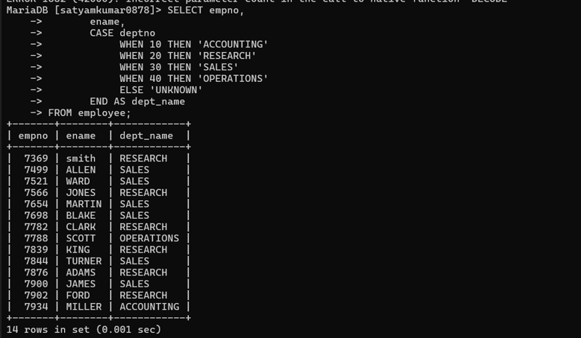

- Display your age in days.
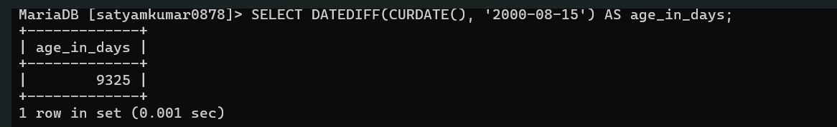
- Display your age in months
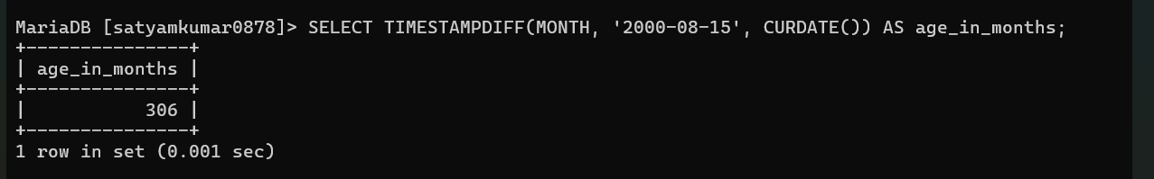

- Display the current date as 15th August Friday Nineteen Ninety-Seven.
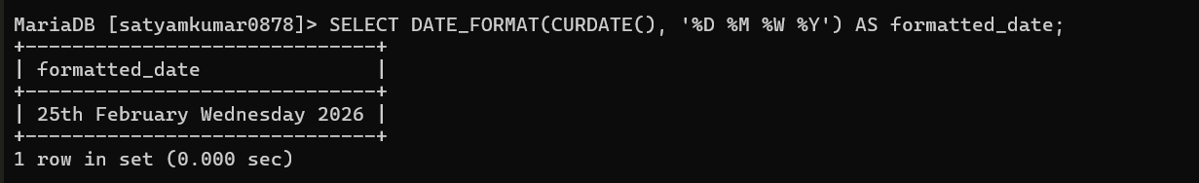

- Display the following output for each row from employee table.

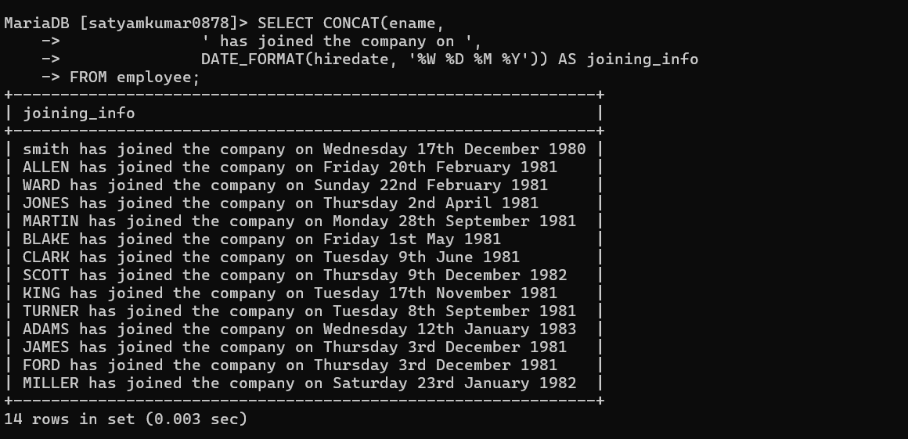

- Scott has joined the company on Wednesday 13th August Nineteen Ninety



7. Find the date for nearest Saturday after current date.
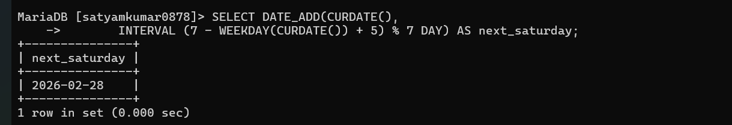

8. Display current time.
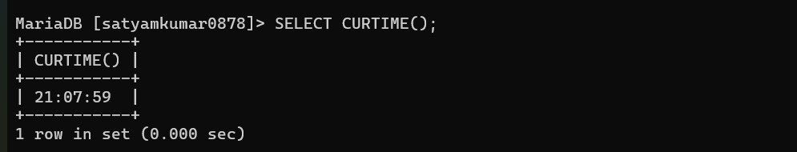

9. Display the date three months Before the current date
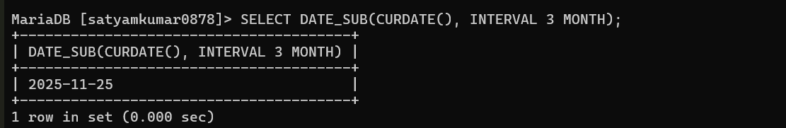

10. Display those employees who joined in the company in the month of Dec.
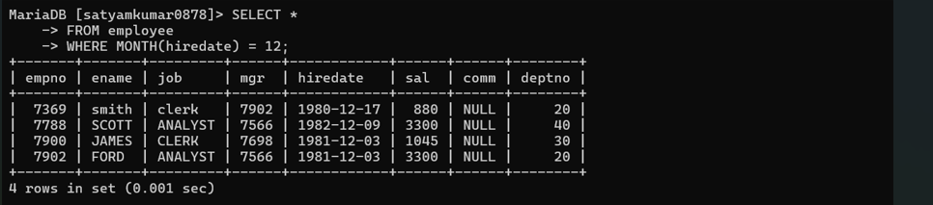

11. Display those employees whose first 2 characters from hire date -last 2 characters of salary.
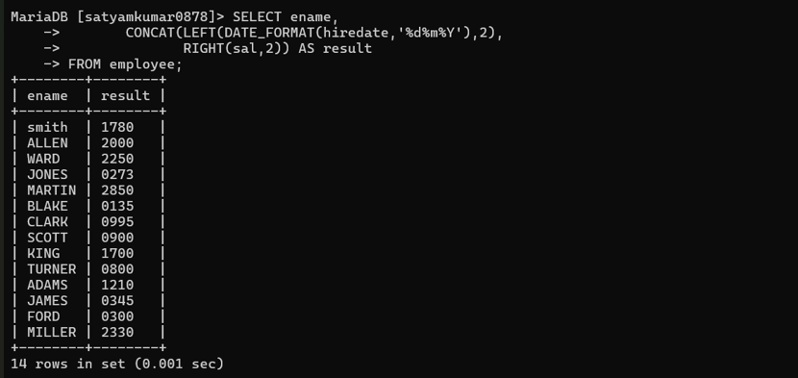

12. Display those employees whose 10% of salary is equal to the year of joining.

13. Display those employees who joined the company before 15 of the months.
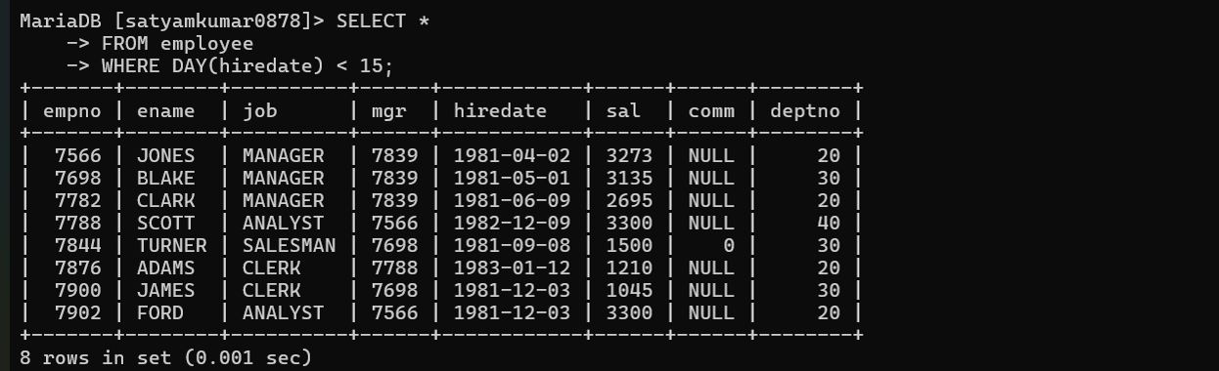

14. Display those employees who has joined before 15th of the month
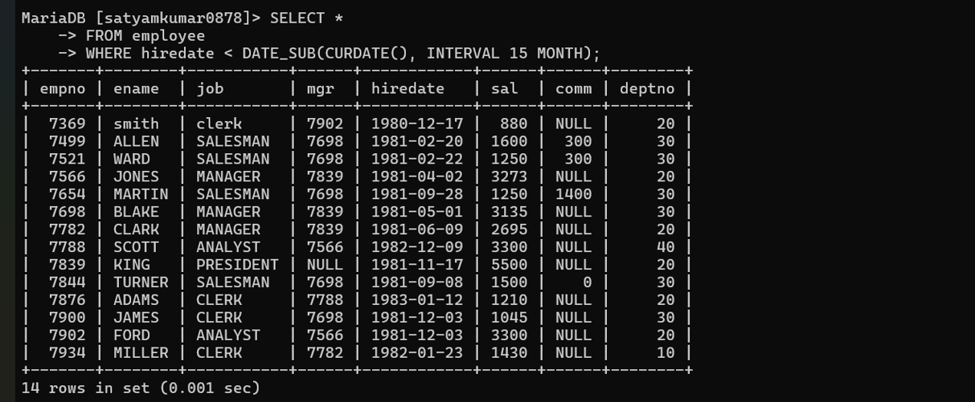

15. Display those employees whose joining DATE is available in deptno
